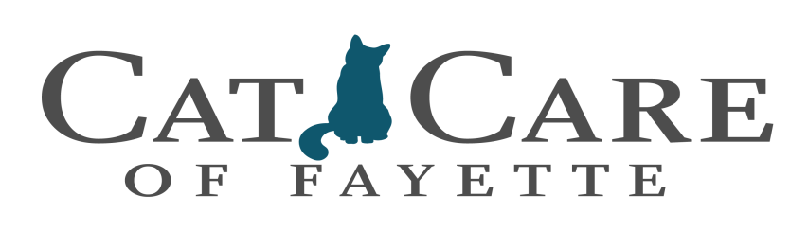

Dental Procedure Form

Owner’s name: _______________________________________ Date: _____________________
Phone Number where you can be reached today: _________________________________________
Would you like text updates? Yes No Text number: _________________________________
Pet’s name: _____________________________ Vaccine History: Current Update Today

Many pets require sedation before a thorough examination can be completed.
The condition of each tooth must be evaluated before a decision is made as to the best course of treatment. It is sometimes impossible to give an accurate estimate before sedation. From a financial standpoint, it is more economical to complete all needed dental procedures during the initial visit and sedation.

Please check the appropriate option:

Perform whatever procedures and extractions are required
Perform whatever procedures and extractions are required up to $ ____________
Perform only the requested dental prophy procedure at this time
Call me after the sedation and exam with an estimate if any additional procedures are needed

Did your pet eat this morning? Yes No Do Not Know
Any vomiting, coughing, sneezing, or diarrhea? Yes No Do Not Know
Has your pet been ill or injured in the past 30 days? Yes No Do Not Know
Has your pet ever had an anesthetic problem? Yes No Do Not Know
Is your pet allergic to any drugs? Please list: Yes No Do Not Know
_______________________________________________________________________

Is your pet currently on any medications? Please list: Yes No Do Not Know
_______________________________________________________________________

Skip following box ONLY if we have a COMPLETE Medical History on file for your pet:

Has your pet been checked for FELV/FIV? Yes No Do Not Know
Is your pet on heartworm preventative? Yes No Do Not Know
Does your pet have a history of seizures? Yes No Do Not Know

Pre-Anesthetic Screening Consent: $ 127.50 (1-7yrs) $162.50(7+ years)

For the enhanced protection of our patients, we will perform a pre-surgical screening of all pets prior to administration of anesthetics. Although we do a pre-surgical examination, many conditions, including disorders of the kidneys, liver and blood cannot be detected without blood lab screening. Pets that are over the age of seven years old require a more extensive blood screening.

I DO I DO NOT authorize my pet to have pre-anesthetic screening

Pain Relief Consent:

For the comfort of our patients, we provide a pain relief injection immediately following surgery. This injection allows the pet to rest and enhances the pet’s recovery. Take home tablets are also available for pets needing additional pain relief at an additional cost.

IV Catheter and fluids Consent: $27.00

We recommend intravenous fluid therapy during all surgical procedures to maintain hydration and venous pressure. This also provides an available port for injection of emergency medications if needed.

I DO I DO NOT authorize my pet to have an IV Catheter

HomeAgain Microchip Consent: $53.50

For the safety of our patients, we recommend a microchip implant to assure the safe return of any lost pets. While your pet is sedated is the best time to inject the implant.

I DO I DO NOT authorize my pet to be implanted with a microchip

If your pet’s vaccine history is not verifiably current,
your pet will receive all mandatory vaccines if possible.
Pets with visible traces of fleas will be given a capstar
At the additional cost of $10.75

I authorize Cat Care of Fayette to examine and treat my pet, and by signing below declare that I have authority to approve such treatment. Signer agrees to take financial responsibility in the event the doctor suffers damages due to treatment that was fraudulently, or improperly, authorized by signer.

I understand that I am responsible for all charges incurred and must pay for those charges in full upon services being rendered. (We do not accept checks as a form of payment)

Owner/Agent Signature: _________________________________________ Date: ______________

Technician Initials _____________

